CS 535 Computer Graphics
Homework Assignment 4-2 (20 points)
Due: 10/11/2024

- In line 2 of slide 88 of the notes “3D Data Structures, 3D Data Management and 3D Models”, number of vertices (numVertices) is set as $\left(prec+1\right)*(prec+1)$ even though the sphere is divided into $prec$slices and each slice is divided into $prec$ segments. Why? (2 points)

- In the above case, how many VAOs and VBOs are needed for the sphere to be rendered? Remember the sphere is textured and shaded (that is, a normal vector is needed for each vertex) ? (2 points)

- Test run example program 4-4 (to show the solar system using matrix stack), but use a pyramid, instead of a cube, to represent the earth. Attach a screen shot of your test run result. (6 points)

4. The scan-line hidden surface elimination method is an extension of the 2D polygon scan conversion method. The 2D scan conversion method processes one polygon at a time while the scan-line hidden surface elimination method can process multiple polygons simultaneously. Using the scan-line method to eliminate hidden surfaces, one needs to build two tables: a bucket-sorted edge table (ET) and a polygon table (PT), and maintains two lists: an active edge list (AEL) and an active polygon list (APL). Given the following projected polygons, the current scan line and the current span, please answer the following questions:
(i) how many edges are contained in the ET?
(ii) how many polygons are contained in the PT?
(iii) how many edges are contained in the current AEL?
(iv) how many polygons are contained in the current APL? (4 points)

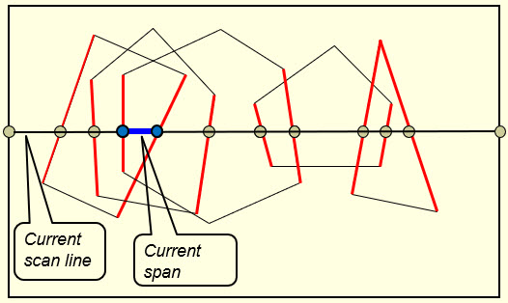

- Can Z-buffer method handle piercing polygons like the case shown below? Justify your answer. Note that part of polygon P2 is blocked by polygon P1 and part of polygon P1 is blocked by polygon P2. (2 points)

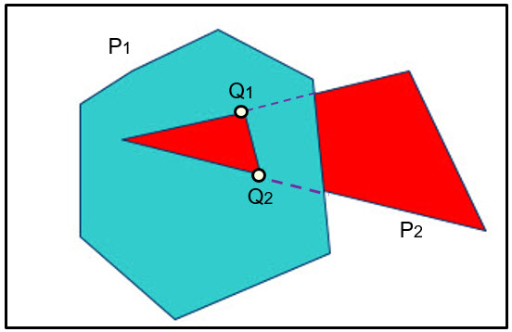

- The BSP tree method is basically a polygon sorting method. By sorting polygons using a BSP tree and then rendering polygons in the sorted order, one can eliminate hidden surfaces through the "overwriting" process. Given the following 5 polygons, what is the minimum number of polygons that could be added to a BSP tree? What is the maximum number?

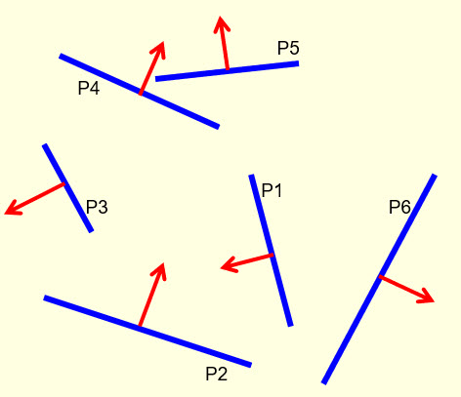

To help you figure out all possible BSP trees that you could get, the following figure is provided. (4 points)
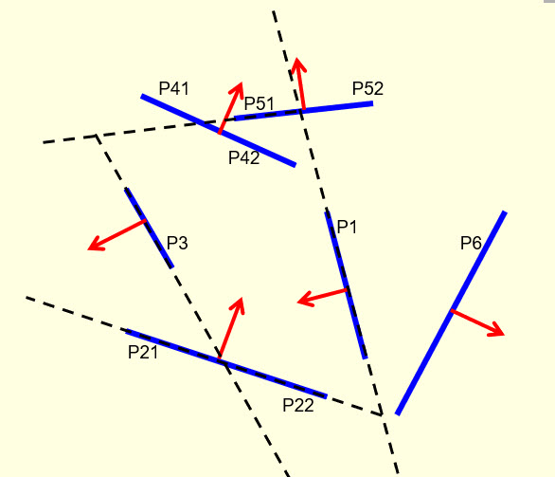
\

- Solutions must be typed (word processed) and emailed to me both as a pdf file and a word document before 23:59 on 10/10/2024.
- Please name your files as:
CS535_HW4-2_2024f_LastName.docx / CS535_HW4-2_2024f_LastName.pdf

