CS 535 Computer Graphics
Homework Assignment 4-1 (20 points)
Due: 10/04/2024

- Modify the first example program for the notes “3D Data Structures, 3D Data Management and 3D Models” to replace the cube with the following pyramid. Be sure to properly specify the number of vertices in the glDrawArrays() command. (5 points)
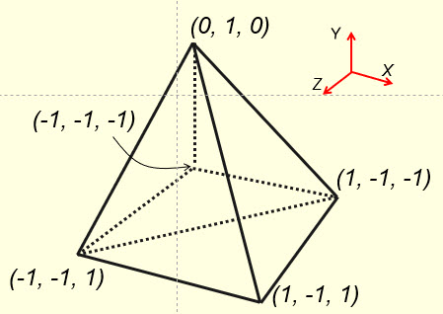

- OpenGL lists the vertices of a triangle in a counter-clockwise direction with respect to the outward normal of the triangle for a 3D object. Why? (2 points)

- Propose a practical use for glCullFace(GL_FRONT_AND_BACK). (5 points)

- What is the purpose of ‘clearing the depth buffer’ each time through display() in a 3D case and what is the purpose of ‘clearing the color buffer’ each time through display() in a 3D case? (5 points)

- In an OpenGL program, one can put computation of the perspective matrix in display() or in init(). Would there be any difference between these two choices? (3 points)

- Solutions must be typed (word processed) and emailed to me both as a pdf file and a word document before 23:59 on 10/04/2024.
- Please name your files as:
CS535_HW4-1_2024f_LastName.docx / CS535_HW4-1_2024f_LastName.pdf

