CS 535 Computer Graphics
Homework Assignment 2 (40 points)
Due: 9/17/2024

- (6 points)
OpenGL has four buffers: color buffer, depth buffer, accumulation buffer and stencil buffer. Each buffer has a specific function/purpose. For instance, a stencil buffer is used to mask pixels in an image, to produce special effects. A color buffer, the so-called frame buffer, is where the image to be shown on screen stored. What are the functions of the depth buffer and the accumulation buffer? Put your answer in the following text boxes for each of them.

Depth buffer:

Accumulation buffer:

- (8 points)
Modern 3D graphics programming utilizes a pipeline. Each stage of the pipeline is done by a specific hardware. In the following chart, fill out the blanks for the names of those stages.
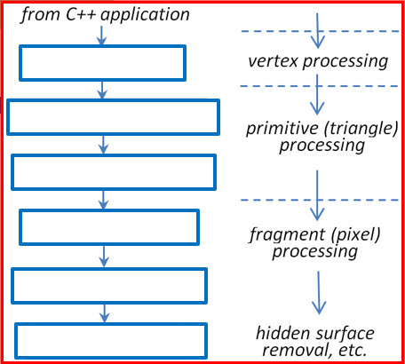 (6 points)
Some of the stages are programmable and some are not. Which one(s) are not programmable and why?

(2 points)

- Based on example programs 1-6 in the notes “OpenGL and Shaders”, write a simple C++/openGL program to show one of the following hollow blue squares of dimension 50x50 (pixels) at the center of your glfw window, the white (black) portion is of dimension 25x25 (pixels). Use “CS535-2024f-HW2-Question 3” as the title of your glfw window and use black as the background color of your glfw window. Your vertex shader and fragment shader can be hard-coded in the C++/openGL program or written in separate glsl files.
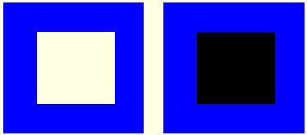
Take a screen shot of the output of your program (make sure the window title is included in the screen shot) and include the screen shot in your HW2 submission, or turn in the screen shot as an attachment to your HW2 submission. Turn in your program as an attachment too. (10 points)

- “Event handling” used to be done by the openGL command “glutMainLoop( )”. But now is handled by the command “glfwPollEvent( )” in a while loop. The first instruction in that while loop is the “display( )” function. What is the advantage of this kind arrangement? Put your answer in the following blank. (6 points)

- What would happen to your program for Question #3 once it is executed if an event other than clicking the “x” symbol at the upper-right corner of your glfw window, such as “pushing a keyboard key” or “clicking at an arbitrary point inside the glfw window” is generated and why? (5 points)

- Depth buffer and color buffer should both be cleared when doing hidden surface elimination (slide 61 of the notes “OpenGL and Shaders”). Why? (5 points)

- Solutions must be typed (word processed) and emailed to me both as a pdf file and a word document before 23:59 on 9/17/2024.
- Name your docx file and pdf file as follows:
CS535-2024f-HW2-LastName.docx / CS535-2024f-HW2-LastName.pdf

