CS375 Homework Assignment 8 (40 points)
Due date: 11/20/2024
- (4 points)
Fill out the following blanks for the instructions of a Turing machine that accepts the language $\left\{c^{n}a | n∈N\right\}$. Use smallest possible non-negative integers to represent the states of the TM.

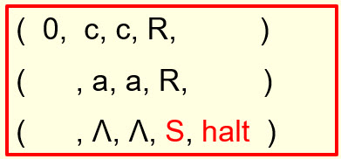

2. (6 points)
Fill out the following blanks for the instructions of a Turing machine that accepts the language $\left\{c^{n}aa | n∈N\right\}$. Use smallest possible non-negative integers to represent the states of the TM.

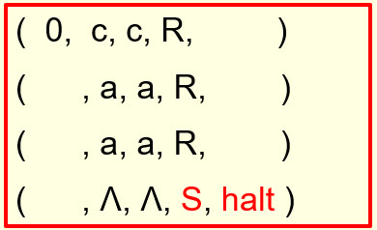

- (12 points)
Fill out the following blanks for the instructions of a Turing machine that moves an input string over {b, c} to the right one cell position. The read/write head of the control unit initially is at the left end of the input string. The rest of the tape cells are blank. The TM will move the entire string to the right one cell position and leave all remaining tape cells blank. The read/write head ends at the right end of the output string. The Turing machine has the following states:

State 0: the initial state
State 1: indicates the TM holds a ‘c’ in its hand
State 2: indicates the TM holds a ‘b’ in its hand

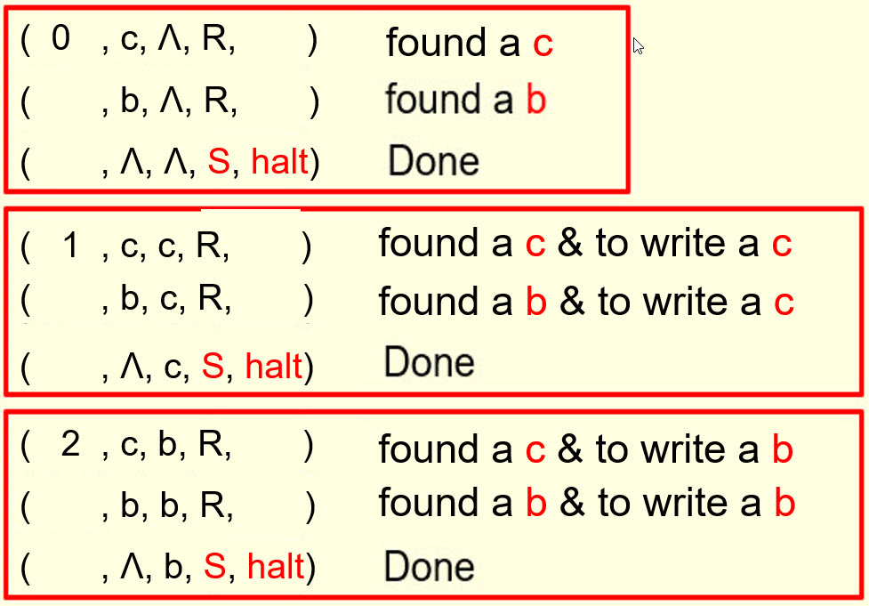

- (18 points)
To move an input string over {b, c} to the right two cells position, we can use the above TM twice. It is also possible to move a string to the right two cells position directly. Such a TM has the following states:
State 0: the initial state
State 1: indicates the TM holds a ‘c’ in its hand
State 2: indicates the TM holds a ‘b’ in its hand
State 11: indicates the TM holds ‘cc’ in its hand
State 12: indicates the TM holds ‘cb’ in its hand
State 10: indicates the TM holds ‘cɅ’ in its hand
State 21: indicates the TM holds ‘bc’ in its hand
State 22: indicates the TM holds ‘bb’ in its hand
State 20: indicates the TM holds ‘bɅ’ in its hand
State halt: the last state

Fill out the blanks in the following instruction set to make it an instruction set for such a TM. (1 point for each blank)

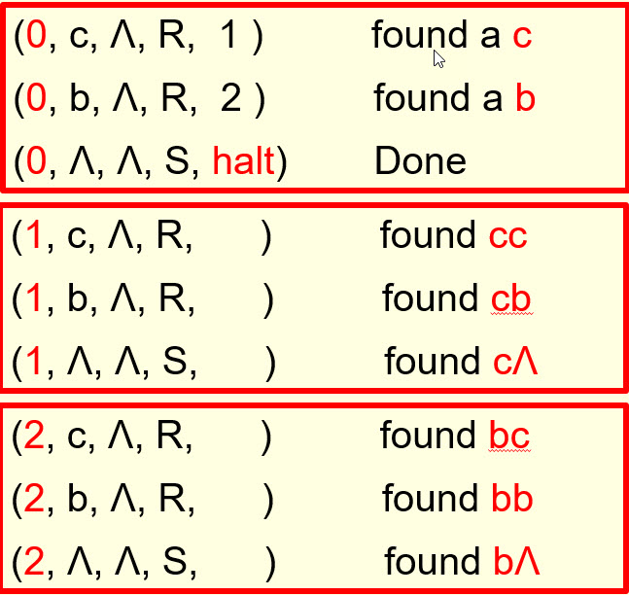

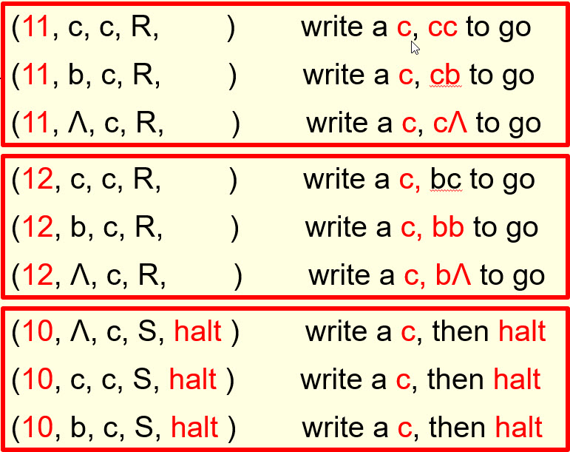

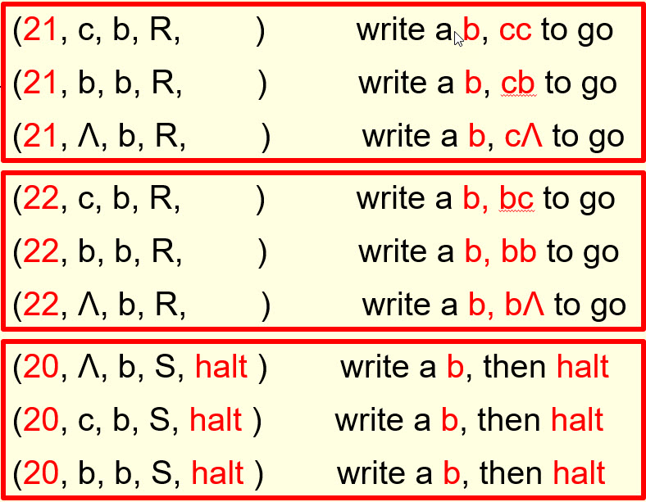

- Solutions must be typed (word processed) and submitted both as a pdf file and a word file to Canvas before 23:59 on 11/20/2024.
- Don’t forget to name your files as
CS375_2024f_HW8_LastName.docx / CS375_2024f_HW8_LastName.pdf

