CS375 Homework Assignment 2 (40 points)
Due Date: January 28, 2025
(The red boxes are text boxes. You can put your answers into the boxes directly)
- For each of the following regular expressions find a language (i.e., a set of strings) over A = {a,b,c} that can be represented/described by that expression. (8 points)
a. $ab^{*}+a^{*}bc$ b. $a^{*}bbbc^{*}$
a.
b.

- Find a regular expression to describe the following language. If it has no regular expression, say so and explain why.
$\{ a, b, bac, bc, b^{2}ac^{2}, bc^{2}, …, b^{n}ac^{n}, {bc}^{m}, … \}$ (2 points)

- A regular expression for the language over the alphabet {a, b} with each string containing exactly one ‘ab’ substring is b*a*abb*a*. Use this result to find regular expressions for the following languages

- a language over the same alphabet with each string containing two ‘ab’ substrings. (2 points)

- a language over the alphabet {a, b, c} with each string containing exactly one ‘abc’ substring. (6 points)

- If a regular expression for the language over the alphabet {a, b} with no string containing the substring aa is (b+ab)*(Ʌ+a), then what is the regular expression for the language over the alphabet {a, b, c} with no string containing the substring aaa? (4 points)

- The following proof shows that
b(a + b)* + bb(a + b)* + bbb(a + b)* = b(a + b)*
Put the reason for each step in the blank on the right-hand side of that step. If an example in the notes can be used for a step, quote that example. (5 points)
b(a+b)* + bb(a+b)* + bbb(a+b)*

= b(a+b)* + (bb+bbb)(a+b)*

= b(a+b)* + b(b+bb)(a+b)*

= b(a+b)* + bb(a+b)*

= (b+bb)(a+b)*
= b(a+b)*

6. Fill out the blanks in the following figure to make it a DFA that recognizes the expression ab + bb*a. (5 points)

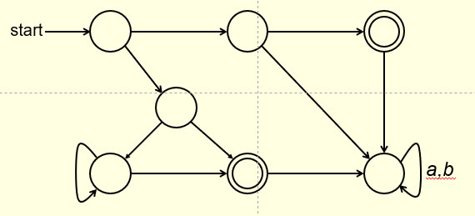

7. Fill out the blanks in the following figure to make it a DFA for the expression b*ac* + bbc + bc (4 points)
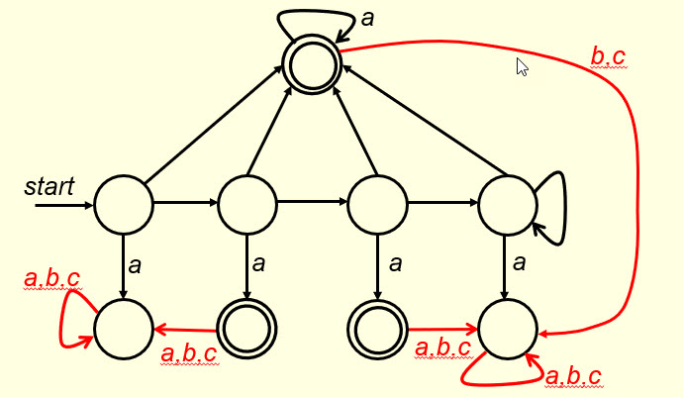

8. Fill out the blanks in the following figure to make it an NFA for the expression
a* + b*a* + b(a+b)*
If it is possible, simplify the given expression first. (4 points)

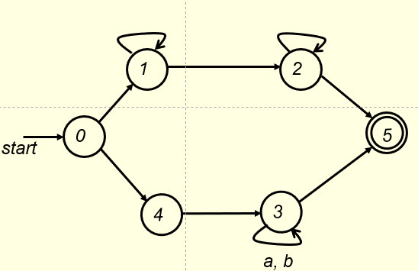

- Solutions must be typed (word processed) and submitted to Canvas both as a pdf file and a
word doc (or docx) file before 23:59 on 01/28/2025.
- Please name your files the following way:
CS375_2025s_HW2_LastName.docx / CS375_2025s_HW2_LastName.pdf

