CS375 Homework Assignment 1 (40 points)
Due date: January 21, 2025
(The red boxes are text boxes. You can put your answers into the boxes directly)

- In the following Venn Diagram, find an expression (in terms of set operations on the sets A, B and C; for instance, the region marked with X2 can be expressed as B−(AUC) ) for the region whose four components are marked with x1, x2, x3 and x4 and put the expression in the red box below. The expression is not unique. Try to make your expression as compact as possible. (4 points)
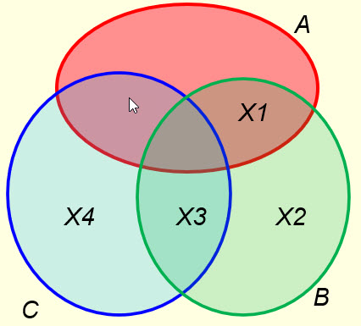
Sol:

- In the above diagram, if |A ∩ B| = 10, |A $∩$B $∩$ C| = 5, |A U B U C| =150 and |X1 U X2 U X3 U X4| = 100 then |A| = ? Show your derivation in the following text box to get partial credit. (4 points)

Sol:

- R is a binary relation over N, the set of natural integers. (x, y) ϵ R iff x = y (mod 7). R defined this way is an RST relation. List all equivalence classes of R in the following box. For each equivalence class, list all the elements in that class. (7 points)

Sol:

- Count the number of strings of length 5 over A = {a, b, c, d, e} that begin with a and contain exactly one b. (5 points).

Sol:

- Use the pigeonhole principle to determine how many people are needed in a group to say that at least three were born on the same day of the month (each month is assumed to have 30 days). (4 points)

Sol:

6. For a set A with m elements and a set B with n elements,
(i) how many different functions f : A → B can be defined if m=4 and n=6? (2 points)

(ii) if m=4 and n=6 then how many different one-to-one functions f : A →B can be defined? (4 points)

= 2 ×( 5 ⁹ - 4 ⁹ )

1
7. Let $f$: N7 → N7 be deﬁned by $f$(x) = (6x+ 5) mod 13. Find $f^{-1}$ if it exists. (4 points).

Sol:

8. Use induction to prove the following equation:

2 + 6 + 12 + ...+ n(n+1) = n(n+1)(n+2)/3

where n ≥ 1 (6 points).

Sol:

- Solutions must be typed (word processed) and submitted to Canvas both as a doc file and a pdf file before 23:59 on 01/21/2025.
- Name your files as:
CS375_HW1_2025s_Lastname.pdf / CS375_HW1_2025s_Lastname.docx

